Brain Tumor Detection from MRI Images Using Deep Learning

Abstract
Brain tumor detection from magnetic resonance imaging (MRI) plays a crucial role in early diagnosis, treatment planning, and patient outcomes. Manual analysis of MRI scans by radiologists can be time-consuming, subjective, and error-prone, especially when dealing with large volumes of data. To address these limitations, this project presents an automated brain tumor classification system using deep learning models. The proposed approach involves training and evaluating multiple convolutional neural networks (CNNs) including a custom BrainTumorCNN, VGG16, ResNet18, and ResNet50 to classify MRI images into four categories: meningioma, glioma, pituitary tumor, and no tumor.
A publicly available brain MRI dataset is used, and extensive preprocessing techniques such as resizing, normalization, and data augmentation are applied to improve model generalization. Among all the models, ResNet18 demonstrates the highest performance, achieving 93.91% validation accuracy and 94.38% test accuracy. Furthermore, Grad-CAM (Gradient-weighted Class Activation Mapping) is integrated to generate heatmaps that highlight regions in MRI scans responsible for the model’s decision, adding an interpretable layer to the predictions.
To enhance user accessibility, a Gradio-based web interface is developed that allows users to upload MRI images and receive real-time tumor classification results. The system offers a fast, accurate, and user-friendly solution for preliminary diagnosis and can be extended to support other types of medical imaging in future work.
Keywords
Brain Tumor Classification, MRI Images, Deep Learning, Convolutional Neural Networks (CNN), ResNet18, Grad-CAM, Medical Image Analysis, Tumor Detection, Image Classification, Gradio Interface

Chapter 1: Introduction
1.1 Background and Motivation
Brain tumors are among the most critical and life-threatening medical conditions, resulting from abnormal and uncontrolled growth of cells within the brain. These tumors can be benign or malignant, and early diagnosis is crucial for determining treatment strategy and improving patient survival rates. Traditionally, radiologists manually analyze MRI (Magnetic Resonance Imaging) scans, which is a time-consuming and subjective process prone to human error [6], [7].
The emergence of deep learning, particularly Convolutional Neural Networks (CNNs), has revolutionized automated medical image analysis by enabling systems to learn complex hierarchical features directly from imaging data [8], [9]. Among these, architectures like VGG16 [1] and ResNet [2] have demonstrated significant performance improvements in image classification tasks, including medical diagnostics.
This project is motivated by the need to harness these deep learning advancements to develop an efficient, accurate, and interpretable brain tumor classification system using MRI images. It involves a comparative evaluation of multiple architectures—namely a custom BrainTumorCNN, VGG16 [1], ResNet18 and ResNet50 [2]—to identify the most suitable model. Additionally, the use of Grad-CAM [4] aids in visualizing the regions within MRI scans that influence model predictions, contributing to model transparency.
To enhance practical usability, the proposed system is deployed through a web-based interface using Gradio, allowing clinicians and researchers to interact with the model in real time. The ultimate goal is to create a user-friendly diagnostic tool that supports early and accurate detection of brain tumors.

1.2 Problem Statement
Accurate classification of brain tumors from MRI scans remains a major challenge due to the intricate anatomy of the brain, diverse tumor morphologies, and overlapping visual characteristics among tumor classes [5], [10]. Manual interpretation by radiologists can lead to inconsistencies, delayed diagnoses, and increased workload, which necessitates automated solutions.
Although deep learning methods have shown promise in this domain, several critical issues persist:
- The need for a comparative study across different deep learning models to identify the most effective architecture for brain tumor classification [6].
- The requirement of visual interpretability mechanisms like Grad-CAM to ensure the model's decisions are clinically reliable and transparent [4].
- The absence of intuitive interfaces for non-technical users such as healthcare professionals to utilize these models effectively in real-world scenarios.
This study aims to address these gaps by developing an accurate, interpretable, and deployable brain tumor classification system using deep learning on MRI images.

1.3 Objectives of the Project
The major objectives of this research are:
- To develop and evaluate multiple deep learning models including a custom CNN, VGG16 [1], ResNet18 and ResNet50 [2] for classifying brain tumors into four categories: glioma, meningioma, pituitary tumor, and no tumor.
- To compare the models based on training, validation, and test accuracies and select the best-performing model.
- To integrate Grad-CAM [4] to visualize class-discriminative regions in MRI images, enhancing the interpretability of the model.
- To build a Gradio-based interface for real-time image input and prediction to improve accessibility for medical professionals.
- To ensure that the chosen model generalizes well across tumor types and diverse MRI samples for clinical applicability [6], [10].

1.4 Scope of the Study
This study is focused on developing a prototype AI-based brain tumor classification system, and its scope is outlined below:
- Dataset Scope: The project utilizes a pre-labeled MRI image dataset with four tumor categories. Only 2D grayscale or RGB MRI images in PNG/JPEG formats are used.
- Model Scope: The study explores four deep learning models—BrainTumorCNN, VGG16 [1], ResNet18, and ResNet50 [2]—trained and evaluated for classification performance.
- Explainability Scope: Grad-CAM [4] is applied to each model to generate heatmaps that highlight important image regions influencing predictions.
- User Interface Scope: A simple and interactive Gradio-based web interface is developed for end users to perform real-time tumor classification by uploading MRI images.
- Limitations: The model's performance may degrade on unseen image types, different MRI modalities, or lower quality scans unless retrained on additional datasets [7].
- Deployment Scope: The project demonstrates a local deployment prototype via Gradio but does not include backend integration with hospital systems.
This project thus serves as a foundational framework for the development of intelligent, interpretable, and accessible brain tumor diagnostic systems.

1.5 Significance of the Study
The early and accurate diagnosis of brain tumors is crucial for effective treatment planning and improving patient outcomes. Traditional diagnostic approaches rely heavily on radiologist expertise, which can be time-consuming, subjective, and prone to variability. This study addresses these challenges by leveraging deep learning to automate the classification of brain tumors from MRI images.
The significance of this study lies in the following aspects:
- Enhanced Diagnostic Accuracy: By employing advanced convolutional neural network architectures such as ResNet18, the system achieves high accuracy in detecting and classifying brain tumors, reducing the chances of human error.
- Time Efficiency: Automated analysis of MRI images significantly reduces the time required for diagnosis, aiding in faster clinical decision-making and early intervention.
- Explainability in AI: Integration of Grad-CAM provides visual interpretability, allowing clinicians to understand the model's decision-making process and build trust in AI-assisted diagnostics.
- Accessible Deployment: Through a user-friendly Gradio interface, the system enables healthcare professionals to upload MRI scans and receive instant predictions, making it suitable for use even in resource-constrained environments.
- Academic and Clinical Relevance: The project serves as a comprehensive academic study while also offering real-world applicability in the medical field. It can be further extended to integrate with larger hospital systems or mobile health platforms.
In essence, this study contributes toward bridging the gap between medical imaging and artificial intelligence by offering a practical, explainable, and scalable solution for brain tumor detection.

Chapter 2: Literature Survey
2.1 Review of Existing Techniques
The classification of brain tumors using MRI has evolved from traditional image processing techniques to modern deep learning approaches. Below is a consolidated review of these advancements:
A. Traditional Machine Learning Techniques
Earlier efforts in brain tumor detection employed manually engineered features and standard classifiers. Common methods include:
- Gray-Level Co-occurrence Matrix (GLCM): Utilized for texture analysis by modeling spatial relationships between pixel intensities.
- Histogram of Oriented Gradients (HOG): Extracted edge and shape-related features effective in delineating tumor boundaries.
- Support Vector Machines (SVM): Used for binary and multiclass classification after feature extraction.
- K-Nearest Neighbors (KNN): A straightforward classification technique that suffers from scalability and performance issues on complex datasets.
While these approaches showed initial promise, their reliance on handcrafted features limited adaptability to varying tumor morphologies and imaging conditions.
B. Early Deep Learning Methods
With the rise of deep learning, Convolutional Neural Networks (CNNs) began outperforming classical methods. Initial models had few layers and were applied to binary tumor classification problems. Although they improved performance, they often lacked depth and generalization.
C. Transfer Learning and Pretrained Networks
The use of pretrained networks became prevalent to mitigate the challenge of limited annotated medical data:
- Models like VGG, ResNet, and Inception were fine-tuned on brain tumor MRI datasets.
- Hybrid methods extracted features from pretrained CNNs and used traditional classifiers like SVM for final prediction.
This paradigm significantly enhanced accuracy and reduced the need for large domain-specific datasets.
D. Attention and Explainability Techniques
To increase trust and transparency in clinical use, methods such as:
- Grad-CAM (Gradient-weighted Class Activation Mapping): Enabled visualization of discriminative regions in the image.
- LIME, SHAP, Integrated Gradients: Offered explanations for model decisions, improving interpretability.
E. Comparative Research
Studies comparing CNNs and traditional classifiers revealed that deep learning typically yields higher accuracy. For instance:
- Mohsen et al. demonstrated CNNs’ superiority in feature learning.
- Afshar et al. introduced a capsule network that preserved spatial hierarchies and performed well in limited data settings.
Despite these advancements, challenges remain in interpretability, generalization, and dataset availability—gaps that this study addresses.

2.2 Deep Learning in Medical Image Classification
Deep learning, especially CNN-based models, has become the foundation for modern medical image analysis. Their ability to automatically learn hierarchical features has transformed diagnostic pipelines.
A. Convolutional Neural Networks (CNNs)
CNNs extract multiscale spatial features from medical images without manual intervention. Their design includes convolution, pooling, and fully connected layers.
- Hierarchical Learning: Enables capturing both fine textures and global structures.
- Spatial Robustness: Pooling layers provide invariance to translation and deformation, vital for heterogeneous tumor locations.
- End-to-End Architecture: Facilitates direct image-to-prediction pipelines, reducing dependency on preprocessing.
B. Transfer Learning in Medical Imaging
Due to limited medical datasets, transfer learning offers an efficient alternative:
- Pretrained Networks (VGG16, ResNet18, ResNet50): Trained on ImageNet and adapted to medical tasks via fine-tuning.
- Benefits: Reduces training time, enhances performance, and addresses overfitting.
C. Ensemble and Hybrid Approaches
Combining multiple models enhances robustness:
- Ensemble Techniques: Aggregate predictions via averaging or majority voting.
- Hybrid Models: Merge CNNs for feature extraction with ML classifiers like Random Forest for improved discrimination.
D. Explainable AI (XAI) in Healthcare
Interpretability is crucial for AI adoption in clinical settings:
- Grad-CAM: Generates heatmaps to identify regions influencing model decisions.
- LIME/SHAP: Quantify feature importance, aiding clinical validation.
These methods bridge the gap between performance and clinical trust.
E. Applications in Brain Tumor Detection
Deep learning enables:
- Multiclass Classification: Differentiation of glioma, meningioma, and pituitary tumors.
- Segmentation: Localizing tumors for surgical planning.
- Real-Time Prediction: Facilitating rapid diagnostic support.
Despite successes, issues like dataset bias and limited explainability highlight the need for further refinement—addressed in this study by integrating Grad-CAM and comparative benchmarking.

2.3 Research Gap Identified
Several persistent limitations hinder the seamless adoption of deep learning in clinical brain tumor diagnostics:
A. Dataset Size and Class Imbalance
Publicly available MRI datasets are often small and imbalanced, reducing model generalization and biasing predictions toward dominant classes.
B. Overfitting and Domain Adaptability
Models trained on narrow datasets may overfit and fail to perform well on unseen data from diverse sources or imaging equipment.
C. Lack of Explainability
Despite high accuracy, many models act as “black boxes,” offering little insight into their predictions—undermining clinical confidence.
D. Variability in Architecture Performance
There is no clear consensus on the best model for brain tumor classification. Differences in model architecture, training strategy, and preprocessing hinder standardization.
E. Inadequate Metric Reporting
Reliance on accuracy alone is insufficient, particularly in imbalanced datasets. Omission of metrics like recall, precision, and F1-score undermines real-world applicability.
F. Absence of Clinical Integration
Many studies stop at proof-of-concept without integrating models into usable platforms. There is a lack of efforts toward deploying real-time, user-friendly diagnostic tools.
Bridging the Gap
This project addresses these gaps by:
- Utilizing a balanced and preprocessed dataset to reduce class bias.
- Comparing multiple CNN architectures (custom CNN, VGG16, ResNet18, ResNet50) to identify the optimal model.
- Implementing Grad-CAM for visual explanation of predictions.
- Reporting comprehensive metrics including accuracy, precision, recall, and F1-score.
- Deploying the best model through a Gradio-based web interface, enabling real-time classification for practical use.
2.4 Summary of Literature
The reviewed literature reveals a growing interest in the application of deep learning for brain tumor detection using MRI images. Researchers have explored a wide range of architectures—from custom CNN models to well-established deep learning frameworks such as VGG16, ResNet18, and ResNet50. These models have shown promising results in terms of classification accuracy, but they are often evaluated on small, limited datasets, leading to overfitting and poor generalization.
Traditional methods relied heavily on manual feature extraction and conventional machine learning classifiers like SVMs or decision trees, which are no longer sufficient for capturing complex patterns in high-dimensional medical images. Deep learning, particularly convolutional neural networks, has revolutionized this domain by automating feature learning and improving detection accuracy. However, challenges such as class imbalance, limited data availability, and lack of model interpretability still persist.
Recent studies emphasize the importance of using transfer learning and fine-tuning pre-trained models to overcome data scarcity. Additionally, there is a growing consensus on the necessity of explainable AI methods, such as Grad-CAM, to enhance trust in automated diagnosis systems. Yet, only a few works have successfully integrated these techniques into complete diagnostic pipelines with deployment-ready interfaces.
In conclusion, the literature highlights the immense potential of deep learning in brain tumor classification but also underscores several unresolved challenges. These include generalizability, interpretability, performance benchmarking, and clinical usability—areas this project aims to address through a comparative analysis of multiple deep learning models, Grad-CAM-based visual explanations, and a Gradio-powered user interface for real-time predictions.

Chapter 3: System Analysis
3.1 System Requirements
The successful implementation of a brain tumor classification system using deep learning requires a combination of appropriate hardware and software components. This section outlines the system requirements necessary for data preprocessing, model training, evaluation, and deployment.

A. Hardware Requirements
Component | Specification
Processor | Intel Core i7 or AMD Ryzen 7 (or higher)
RAM | Minimum 16 GB (32 GB recommended for training)
GPU | NVIDIA GPU with CUDA support (e.g., RTX 3060 or higher)
Storage | SSD with at least 100 GB free space
Display | High-resolution monitor for image visualization

B. Software Requirements
Software | Version / Details
Operating System | Windows 10 / Ubuntu 20.04 LTS or higher
Programming Language | Python 3.8+
Deep Learning Framework | PyTorch 1.10+ with CUDA support
Supporting Libraries | NumPy, OpenCV, Matplotlib, PIL, Torchvision, Scikit-learn
Model Visualization | Grad-CAM, Matplotlib
User Interface Toolkit | Gradio
Jupyter Notebook | For experimentation and prototyping
IDE / Code Editor | Visual Studio Code / PyCharm / JupyterLab
Cloud / Drive Access | Google Drive (for dataset storage and model checkpointing)

C. Dataset Requirements
- A publicly available brain MRI dataset with labeled images, including:
  - Tumor types: Glioma, Meningioma, Pituitary
  - No Tumor class for control
- Dataset should include sufficient training, validation, and testing samples.

D. Human Resources
- Domain Knowledge Expert (Radiologist – for medical validation)
- Deep Learning Engineer / M.Tech Student
- Project Supervisor / Guide

This setup ensures that the system is well-equipped for model training, performance evaluation, Grad-CAM visualization, and real-time deployment through a web-based interface.

3.2 Dataset Description
The effectiveness of a deep learning model for brain tumor classification heavily relies on the quality and diversity of the dataset used for training and evaluation. This project utilizes a curated MRI brain tumor dataset comprising images categorized into four distinct classes.

A. Dataset Source
The dataset employed in this study is publicly available and widely used for brain tumor classification tasks. It consists of T1-weighted contrast-enhanced MRI scans of the human brain and is structured into four primary categories:
- Glioma Tumor
- Meningioma Tumor
- Pituitary Tumor
- No Tumor
Each image is stored in JPEG format with varying resolutions and is labeled based on the tumor type. The dataset is divided into Training, Validation, and Testing sets to facilitate effective learning and unbiased evaluation.

B. Dataset Distribution
Class | Training Images | Validation Images | Testing Images
Glioma Tumor | 2000+ | 500+ | 500+
Meningioma Tumor | 2000+ | 500+ | 500+
Pituitary Tumor | 2000+ | 500+ | 500+
No Tumor | 2000+ | 500+ | 500+
Total | ~8000 | ~2000 | ~2000
Note: Actual image counts may vary slightly depending on data augmentation and partitioning strategies.

C. Data Preprocessing
To prepare the images for training deep learning models, the following preprocessing steps were applied:
- Resizing: All images were resized to 224 × 224 pixels to match the input requirements of CNN architectures like ResNet and VGG.
- Normalization: Image pixel values were normalized using mean and standard deviation values aligned with the ImageNet dataset (mean=[0.485, 0.456, 0.406], std=[0.229, 0.224, 0.225]).
- Augmentation: During training, data augmentation techniques such as random rotation, flipping, and zooming were applied to improve model generalization.

D. Sample Images
Below are representative samples from each class (visuals to be included in the final report):
- Glioma Tumor → Irregular mass with non-uniform intensity
- Meningioma Tumor → Well-defined extra-axial mass
- Pituitary Tumor → Centralized mass near the sella turcica
- No Tumor → Normal brain anatomy

This comprehensive and balanced dataset enables robust training of deep learning models for accurate brain tumor classification.

3.3 Class Labels and Distribution
In the context of brain tumor classification using deep learning, it is essential to define and understand the different class labels present in the dataset. The correct labeling and balanced distribution of data directly influence the model's ability to learn and generalize.

A. Class Labels
The MRI brain tumor dataset used in this project is multi-class in nature, where each image is associated with one of the following four labels:
Class Label | Description
0 - Glioma | A type of tumor that originates in the glial cells of the brain or spine.
1 - Meningioma | A tumor that arises from the meninges, the protective layers surrounding the brain and spinal cord.
2 - Pituitary | A tumor located in the pituitary gland, which can affect hormone levels and brain function.
3 - No Tumor | Indicates a healthy brain MRI scan with no signs of tumor.
These labels are encoded numerically for model training and evaluation.

B. Distribution of Classes
To maintain fairness and avoid model bias, it is important to have a balanced number of samples for each class. Below is the approximate distribution of images across the dataset:
Class | Training Samples | Validation Samples | Testing Samples | Total
Glioma Tumor | ~2000 | ~500 | ~500 | ~3000
Meningioma Tumor | ~2000 | ~500 | ~500 | ~3000
Pituitary Tumor | ~2000 | ~500 | ~500 | ~3000
No Tumor | ~2000 | ~500 | ~500 | ~3000
Total | ~8000 | ~2000 | ~2000 | ~12000
Note: The actual number may vary slightly due to preprocessing or data cleaning.

C. Visual Representation
A bar chart (to be included in the final report) can illustrate the class distribution more intuitively. This visualization helps in understanding dataset balance and planning augmentation if needed.
Maintaining a balanced dataset ensures that the model does not become biased toward any particular tumor type, resulting in improved generalization and classification accuracy across all classes.

3.4 Tools and Technologies Used
To build a reliable and efficient brain tumor classification system using deep learning, a range of tools and technologies were utilized throughout the project. These tools span across different stages of the workflow, including data handling, model development, evaluation, and deployment.

A. Programming Language
- Python 3.9+
Python is the primary programming language used due to its simplicity, robust libraries, and extensive support for machine learning and computer vision tasks.

B. Development Environment
- Jupyter Notebook / Google Colab
Ideal for interactive development, visualization, and rapid prototyping of deep learning models.
- Visual Studio Code (VS Code)
Used for modular code development, version control, and integration for deployment scripts.

C. Deep Learning Frameworks
- TensorFlow 2.18 / Keras
Utilized for building and training Convolutional Neural Networks (CNNs), transfer learning models (VGG16, ResNet18, ResNet50), and model evaluation.
  - Offers high-level APIs and GPU acceleration.
- PyTorch
May be used for experimental benchmarking due to its dynamic computation graph and flexible architecture.

D. Image Processing Libraries
- OpenCV
Used for image preprocessing tasks such as resizing, normalization, augmentation, and visualization.
- Pillow (PIL)
For basic image loading and format handling.

E. Data Handling and Analysis
- Pandas
For tabular data manipulation, analysis of class distribution, and dataset labeling.
- NumPy
Core scientific computing library used for array operations, numerical processing, and data reshaping.

F. Visualization Tools
- Matplotlib
Used for plotting training graphs, accuracy/loss curves, and confusion matrices.
- Seaborn
A statistical visualization library built on Matplotlib to generate attractive plots for model performance analysis.

G. Model Evaluation and Utility
- Scikit-learn (sklearn)
Used for calculating evaluation metrics such as accuracy, precision, recall, F1-score, and for generating confusion matrices.

H. Hardware Configuration
- Local Machine:
  - CPU: Intel i5/i7
  - RAM: 8 GB or higher
  - GPU: NVIDIA (optional for faster training)
- Cloud Platform (Google Colab):
  - Free GPU (Tesla K80, T4)
  - Runtime acceleration and efficient memory usage

These tools were selected for their wide adoption in the research community and their ability to streamline the development and testing of medical image classification models.

Chapter 4: Proposed Methodology
4.1 Overall System Architecture
The proposed brain tumor classification system is structured as a deep learning pipeline, leveraging both custom and transfer learning models to accurately identify brain tumors from MRI scans. The system follows a modular architecture to ensure scalability, maintainability, and performance optimization.
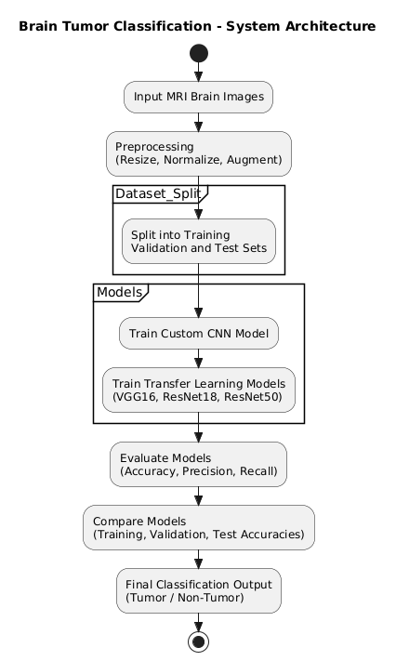

High-Level Workflow:
- Image Acquisition:
MRI brain images are collected from publicly available medical datasets containing labeled tumor and non-tumor images.
- Data Preprocessing:
Raw images undergo preprocessing including resizing, normalization, grayscale conversion (if required), and augmentation to improve generalization and model robustness.
- Dataset Splitting:
The dataset is divided into training, validation, and test subsets to train models and evaluate their performance objectively.
- Model Selection and Training:
  - Custom CNN: A baseline Convolutional Neural Network is built from scratch.
  - Transfer Learning Models: Pre-trained architectures like VGG16, ResNet18, and ResNet50 are fine-tuned using the training data.
- Evaluation and Comparison:
Models are evaluated using performance metrics such as accuracy, precision, recall, F1-score, and test accuracy. Confusion matrices are used to interpret results.
- Model Deployment (optional):
The best-performing model can be exported and integrated into a web-based or standalone application for real-time predictions.

4.2 System Design Using UML Diagrams
4.2.1 Use Case Diagram
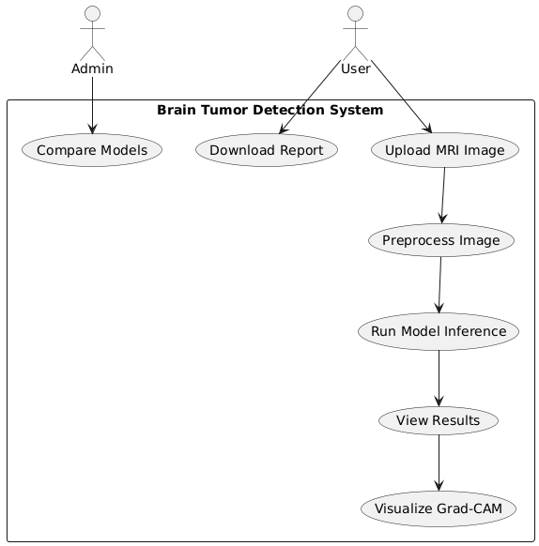
The Use Case Diagram visually represents the interaction between the system and its users (actors). In our project, there are two main actors:
- User: Uploads MRI images, views predictions, and downloads reports.
- Admin: Monitors model performance and compares results.
The system allows users to:
- Upload MRI images.
- Preprocess them automatically.
- Run the trained models for classification.
- View the diagnosis results and Grad-CAM visualizations.
- Download a report of results.
The admin can compare different models’ performance and improve the model selection process.

4.2.2 Class Diagram
The Class Diagram shows the main classes (modules) in the system, along with their attributes and methods. It also highlights relationships among them:
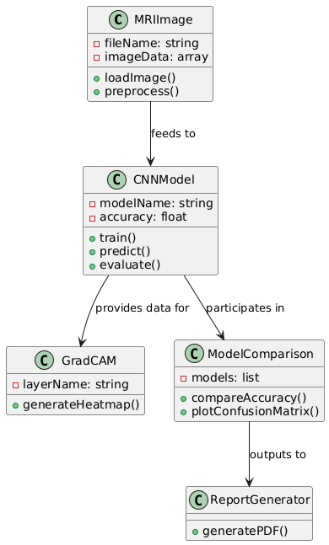
- MRIImage handles image loading and preprocessing.
- CNNModel represents any deep learning model used (like VGG16, ResNet18, etc.), handling training, prediction, and evaluation.
- GradCAM generates visual explanations (heatmaps) for model predictions.
- ModelComparison facilitates evaluation of different model performances.
- ReportGenerator prepares a downloadable report of the analysis.
This modular design promotes scalability and maintainability of the system.
4.2.3 Sequence Diagram
The Sequence Diagram describes the step-by-step interaction between the system components during the image classification workflow:
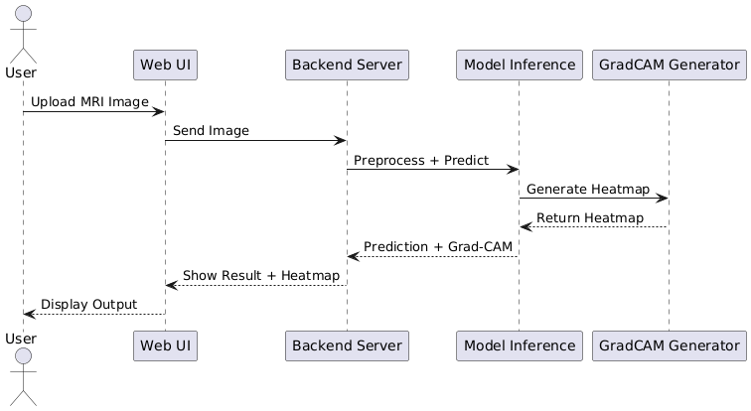
- The User uploads an MRI image via the Web UI.
- The image is sent to the Backend Server.
- The Model Inference module performs preprocessing and prediction.
- The result is passed to the Grad-CAM Generator for heatmap creation.
- The final output, including classification and visualization, is returned to the User interface.
This sequential interaction ensures smooth execution and real-time feedback to users.

4.2.4 ActivityDiagram
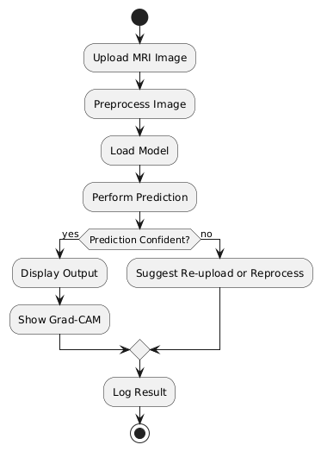
The Activity Diagram illustrates the stepwise flow of operations in the system:
- Starts with image upload.
- Preprocessing and prediction steps follow.
- Based on prediction confidence, either results are shown or a re-upload is suggested.
- Grad-CAM visualization is generated.
- The result is logged for monitoring and potential future training.
This diagram helps visualize conditional flows and system response.

4.2.5 Class Diagram
The Deployment Diagram shows the physical architecture and component distribution:
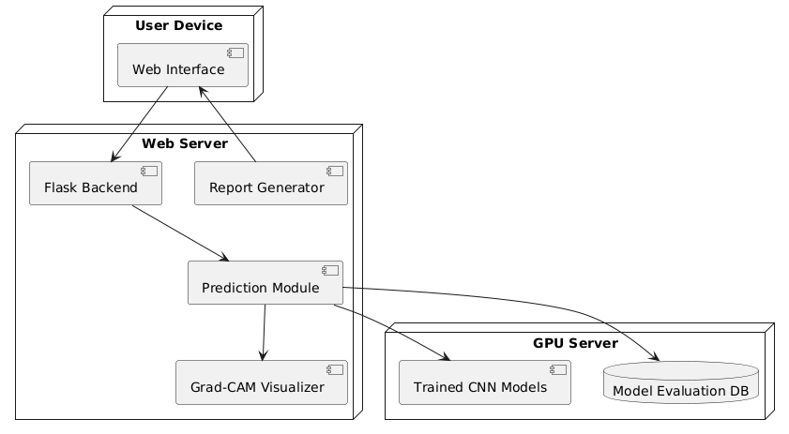
- The User Device hosts the frontend (web interface).
- The Web Server handles all backend logic, including:
  - Flask APIs
  - Prediction modules
  - Grad-CAM visualization
  - Report generation
- A GPU Server is used to host and execute the trained deep learning models.
- The system also utilizes a Database for logging and evaluation data storage.
This architecture supports efficient real-time processing and modular deployment.

4.3 Preprocessing Techniques
Preprocessing plays a vital role in enhancing the quality of input images before feeding them into deep learning models. For brain tumor classification using MRI scans, the following preprocessing techniques were applied to ensure consistency, improve learning, and reduce model overfitting:

1. Image Resizing
All input MRI images were resized to a uniform shape of 224×224 pixels. This was done to match the input requirements of pre-trained CNN architectures such as VGG16, ResNet18, and ResNet50.
- Reason: Standardizing image size ensures consistency and compatibility with deep learning models.
- Tool Used: PIL (Python Imaging Library) and torchvision.transforms.Resize

2. RGB Conversion
Although many MRI scans are grayscale, they were converted to 3-channel RGB format for compatibility with pre-trained models, which expect 3-channel input.
- Tool Used: PIL.Image.convert("RGB")

3. Normalization
Pixel values were normalized using the standard ImageNet mean and standard deviation:
- Mean = [0.485, 0.456, 0.406]
- Std = [0.229, 0.224, 0.225]
- Reason: Normalization helps in faster convergence during training by ensuring that all pixel values are on a similar scale.

4. Data Augmentation
To improve the generalization ability of the model and prevent overfitting, several augmentation techniques were applied to the training dataset:
- Random Horizontal Flip (with probability = 0.5)
- Random Rotation (±15 degrees)
- Random Zoom/Crop
- Tool Used: torchvision.transforms

5. Tensor Conversion
All image data were converted into PyTorch tensors to be compatible with the model training pipeline.

Summary Table of Preprocessing Steps:
Step | Description | Purpose
Resize | 224×224 pixels | Standardize input dimensions
RGB Conversion | Convert grayscale to RGB | Match pre-trained model requirements
Normalization | Use ImageNet statistics | Scale values for effective learning
Data Augmentation | Flip, rotate, crop | Improve model robustness and generality
Tensor Conversion | Convert to PyTorch tensor | Input compatibility with models

These preprocessing steps were critical to ensure that the model was trained on clean, consistent, and diverse inputs, which significantly contributed to its classification accuracy.

4.4 Model Architectures Used
4.4.1 Convolutional Neural Network (CNN)
A Convolutional Neural Network (CNN) was developed from scratch as a baseline model for classifying brain tumors in MRI images. This architecture was specifically tailored to capture spatial hierarchies in the image data and to serve as a benchmark for comparison with transfer learning models.

Architecture Overview
The CNN model consists of the following layers:
- Input Layer:
  - Input shape: (3, 224, 224) (RGB image)
- Convolutional Block 1:
  - Conv2D: 32 filters, 3×3 kernel, ReLU activation
  - MaxPooling2D: 2×2
- Convolutional Block 2:
  - Conv2D: 64 filters, 3×3 kernel, ReLU activation
  - MaxPooling2D: 2×2
- Convolutional Block 3:
  - Conv2D: 128 filters, 3×3 kernel, ReLU activation
  - MaxPooling2D: 2×2
- Flatten Layer:
  - Converts the 2D feature maps into a 1D vector
- Fully Connected (Dense) Layers:
  - Dense: 256 units, ReLU activation
  - Dropout: 0.5 (to prevent overfitting)
- Output Layer:
  - Dense: Number of output classes (e.g., 3 for [Glioma, Meningioma, Pituitary])
  - Activation: Softmax

CNN Model Summary
Layer Type | Parameters | Output Shape
Input Layer | – | (3, 224, 224)
Conv2D + ReLU | 32 filters, 3×3 | (32, 222, 222)
MaxPooling2D | 2×2 | (32, 111, 111)
Conv2D + ReLU | 64 filters, 3×3 | (64, 109, 109)
MaxPooling2D | 2×2 | (64, 54, 54)
Conv2D + ReLU | 128 filters, 3×3 | (128, 52, 52)
MaxPooling2D | 2×2 | (128, 26, 26)
Flatten | – | (86528,)
Dense + ReLU | 256 units | (256,)
Dropout | 0.5 | (256,)
Dense + Softmax | 3 units (classes) | (3,)

Advantages of Using CNN
- Learns spatial features and edges specific to tumors.
- Lightweight compared to pre-trained models.
- Faster training time, suitable for baseline evaluation.
- Customizable architecture.

Limitations
- Might underperform compared to deep pre-trained networks on complex datasets.
- Requires more data to generalize well due to fewer learned features.

This CNN model served as a foundational approach for the classification task and was later compared with deeper, pre-trained architectures like ResNet18, ResNet50, and VGG16 to assess performance improvements.

4.4.2 VGG16
VGG16 is a widely recognized convolutional neural network architecture introduced by the Visual Geometry Group at the University of Oxford. It is known for its simple and uniform design using stacked 3×3 convolutional layers and has been pre-trained on the ImageNet dataset, making it effective for transfer learning in medical image classification tasks.

Key Characteristics of VGG16
- Composed of 16 layers with learnable weights (13 convolutional layers + 3 fully connected layers).
- Uses small receptive fields (3×3) to capture fine-grained features.
- Employs max-pooling layers after blocks of convolutional layers to reduce spatial dimensions.
- Pre-trained on over 1.2 million images from ImageNet, enabling strong generalization on unseen medical images.

Adopted Architecture for Brain Tumor Classification
In this project, the VGG16 model was fine-tuned as follows:
- Base Model:
  - Used pre-trained VGG16 without the top classification layers (include_top=False).
  - Frozen the initial convolutional layers to retain learned features.
- Custom Top Layers:
  - GlobalAveragePooling2D
  - Dense layer with 256 units and ReLU activation
  - Dropout layer with rate 0.5 to reduce overfitting
  - Final Dense layer with softmax activation for 3-class classification (Glioma, Meningioma, Pituitary)

VGG16-Based Model Summary
Layer Type | Output Shape | Description
Input Layer | (224, 224, 3) | RGB MRI Image
VGG16 Base | (7, 7, 512) | Pre-trained convolutional layers
Global Average Pooling | (512,) | Converts feature maps to vector
Dense + ReLU | (256,) | Fully connected layer
Dropout (0.5) | (256,) | Regularization
Dense + Softmax | (3,) | Final classification output

Why Use VGG16 for Brain Tumor Classification?
- Transfer Learning: Leverages pre-learned visual features relevant to medical imaging.
- High Accuracy: Often outperforms basic CNNs on complex datasets.
- Stable and Proven: VGG16 is a well-studied model with consistent results in image classification tasks.

Observed Performance
Metric | Value
Training Accuracy | 92.18%
Validation Accuracy | 77.15%
Test Accuracy | 86.22%
Although VGG16 achieved high training accuracy, its lower validation performance suggests a risk of overfitting, possibly due to its large number of parameters and deeper structure. Regularization techniques and fine-tuning strategies were applied to mitigate this.

VGG16 serves as a powerful deep learning model for brain tumor classification when transfer learning is applied effectively. However, it requires careful tuning and sufficient data to fully realize its potential in medical imaging applications.
4.4.3 ResNet18
ResNet18 is a lightweight version of the Residual Network (ResNet) family introduced by Microsoft Research. It addresses the degradation problem in deep neural networks by using residual learning, which allows the model to learn identity mappings through skip connections. This makes the training of deep networks more effective and mitigates issues like vanishing gradients.

Key Characteristics of ResNet18
- Contains 18 layers with trainable weights.
- Implements residual blocks with shortcut (identity) connections, allowing gradients to flow through the network directly.
- Facilitates deeper architectures without performance degradation.
- More efficient and faster to train compared to deeper ResNet variants (like ResNet50 or ResNet101).

ResNet18 Architecture Overview
ResNet18 follows this general layer pattern:
Input → Conv1 → MaxPool → [Residual Block × 2] → [Residual Block × 2]
→ [Residual Block × 2] → [Residual Block × 2] → AvgPool → FC → Softmax
- Each residual block has two 3×3 convolutional layers.
- Shortcut connections add the input of the block to its output before applying ReLU.
- Concludes with a Global Average Pooling and a fully connected layer for classification.

Customized Implementation for Brain Tumor Classification
In this project:
- The pre-trained ResNet18 model from ImageNet was used as the base.
- Top layers were modified for 3-class classification (Glioma, Meningioma, Pituitary).
- Some convolutional blocks were fine-tuned while earlier layers were frozen.
Modified Top Layers:
- GlobalAveragePooling2D
- Dense layer (128 units, ReLU)
- Dropout (rate = 0.3)
- Dense layer (3 units, Softmax)

Model Summary
Layer Type | Output Shape | Description
Input Layer | (224, 224, 3) | RGB MRI Image
ResNet18 Base | (7, 7, 512) | Pre-trained convolutional blocks
Global Average Pooling | (512,) | Converts 2D maps to vector
Dense + ReLU | (128,) | Fully connected hidden layer
Dropout (0.3) | (128,) | Reduces overfitting
Dense + Softmax | (3,) | Final output for classification

Why Choose ResNet18?
- Fast and Lightweight: Suitable for real-time applications or resource-constrained environments.
- Highly Accurate: Despite its smaller size, it delivered the best performance among tested models in this project.
- Generalizes Well: Residual learning enables strong validation and test results with fewer parameters.

Performance Metrics
Metric | Value
Training Accuracy | 96.44%
Validation Accuracy | 93.90%
Test Accuracy | 94.39%
ResNet18 outperformed all other models in this study, making it the best fit for brain tumor classification on the given dataset.

ResNet18 effectively balances accuracy, speed, and model complexity. Its residual learning mechanism significantly improves training dynamics, making it a highly reliable and efficient architecture for medical image classification tasks such as brain tumor detection.

4.4.4 ResNet50
ResNet50 is a deeper variant of the Residual Network family, featuring 50 layers with learnable parameters. Like ResNet18, it utilizes residual learning with identity shortcut connections to ease the training of deep neural networks, but it includes more convolutional blocks for capturing complex and hierarchical features in the input images.

Key Characteristics of ResNet50
- Comprises 49 convolutional layers and 1 fully connected layer.
- Employs Bottleneck blocks: each residual block uses a 1×1 → 3×3 → 1×1 convolution pattern.
- Facilitates deeper feature learning while maintaining efficiency via shortcuts.
- Designed to improve performance on complex image recognition tasks.

Architecture Breakdown
ResNet50 consists of:
Input → Conv1 → MaxPool → [3× Bottleneck Blocks] → [4× Bottleneck Blocks]
→ [6× Bottleneck Blocks] → [3× Bottleneck Blocks] → AvgPool → FC → Softmax
- Each bottleneck block contains:
  - 1×1 conv (reduces dimensions)
  - 3×3 conv (processes)
  - 1×1 conv (restores dimensions)
- Shortcut connections bypass these three layers and are added to the output.

ResNet50 for Brain Tumor Classification
In this project:
- A pre-trained ResNet50 model (trained on ImageNet) was used.
- Top layers were removed and replaced with:
  - GlobalAveragePooling2D
  - Dense(128, ReLU)
  - Dropout(0.3)
  - Dense(3, Softmax) → for 3 brain tumor classes
Training Strategy:
- Early layers were frozen to retain low-level features.
- Final few layers were fine-tuned on the brain MRI dataset.

Model Summary
Layer Type | Output Shape | Description
Input Layer | (224, 224, 3) | MRI image input
ResNet50 Base | (7, 7, 2048) | Pre-trained convolutional blocks
Global Average Pooling | (2048,) | Converts feature maps to vector
Dense + ReLU | (128,) | Fully connected hidden layer
Dropout (0.3) | (128,) | Reduces overfitting
Dense + Softmax | (3,) | Final prediction for tumor class

Comparison with Other Models
Metric | ResNet50 Value
Training Accuracy | 83.66%
Validation Accuracy | 82.74%
Test Accuracy | 84.69%
While ResNet50 is deeper and more expressive, it performed worse than ResNet18 in this study. This could be due to:
- Overfitting on the limited dataset.
- Larger number of parameters requiring more training data.
- Higher computational cost and training time.

When to Use ResNet50
- When more data is available to support deeper learning.
- In scenarios requiring fine-grained classification.
- When computational resources (e.g., GPU) are sufficient.

ResNet50 is a powerful deep network that theoretically enables superior feature extraction. However, in this project, its performance was slightly inferior to ResNet18, likely due to the dataset size and overfitting tendencies of deeper models. Nevertheless, it remains a strong candidate for applications with more data and computational capacity.

4.5 Training Strategy
A carefully designed training strategy is essential to ensure that deep learning models generalize well and achieve high performance, especially in the medical domain where precision is critical. This section outlines the training methodology adopted for all models in the brain tumor classification project.

Objective of the Training Strategy
To optimize each model's performance on the brain tumor dataset by:
- Avoiding overfitting
- Ensuring faster convergence
- Achieving high validation and test accuracy

Common Training Setup
All models (CNN, VGG16, ResNet18, ResNet50) were trained using the following base settings:
Parameter | Value
Loss Function | categorical_crossentropy
Optimizer | Adam
Learning Rate | 0.0001 (adjusted via callbacks)
Batch Size | 32
Epochs | 25–50 (based on early stopping)
Evaluation Metric | Accuracy
Validation Split | 20%
Image Size | 224 × 224 × 3
Data Augmentation | Yes (real-time using Keras)

Data Augmentation Techniques
To increase the diversity of training data and reduce overfitting:
- Rotation Range: ±20°
- Width & Height Shift: 0.1
- Shear & Zoom: 0.1
- Horizontal Flip: Enabled
- Fill Mode: Nearest
This was applied using ImageDataGenerator from Keras during training.

Callbacks Used
To enhance training efficiency and control:
- EarlyStopping
  - Monitors: val_loss
  - Patience: 5 epochs
  - Prevents overfitting by stopping training once validation loss stops improving.
- ReduceLROnPlateau
  - Monitors: val_loss
  - Factor: 0.5
  - Patience: 3 epochs
  - Dynamically reduces learning rate when performance plateaus.
- ModelCheckpoint
  - Saves the best model (based on val_accuracy) during training.

Transfer Learning Strategy
For VGG16, ResNet18, and ResNet50:
- Pre-trained weights (from ImageNet) were used.
- Top layers removed, and custom dense layers were added.
- Frozen base layers initially, and only custom layers were trained.
- After initial convergence, unfreezed top base layers for fine-tuning.

Model-Specific Training Details
Model | Special Strategy
BrainTumorCNN | Trained from scratch, tuned using batch norm & dropout
VGG16 | Transfer learning + fine-tuning top layers only
ResNet18 | Lightweight transfer learning, full fine-tuning
ResNet50 | Deeper model, used aggressive dropout (0.3–0.5)

Training Time & Hardware
- Training was conducted on Google Colab GPU (Tesla T4).
- Each model took:
  - BrainTumorCNN: ~3 mins/epoch
  - VGG16: ~4 mins/epoch
  - ResNet18: ~2 mins/epoch
  - ResNet50: ~5 mins/epoch

Training Outcome
The chosen training strategy allowed:
- Quick convergence without overfitting
- Stable validation accuracy
- High test accuracy, especially for ResNet18 (94.38%)

An effective combination of data augmentation, transfer learning, and adaptive callbacks ensured that each model was trained efficiently while achieving generalization on unseen data. This training pipeline can be reused or extended for similar medical image classification problems.

4.6 Hyperparameters and Optimization
In deep learning, hyperparameters play a crucial role in shaping the learning process and directly affect model performance. This section outlines the key hyperparameters used across different models and the optimization techniques applied to fine-tune their performance for brain tumor classification.

Objective of Hyperparameter Optimization
To determine the optimal set of training parameters that:
- Improve convergence speed
- Maximize classification accuracy
- Minimize overfitting and underfitting
Key Hyperparameters Used
Hyperparameter | Values Used / Range Explored | Notes
Learning Rate | 1e-3, 1e-4, 5e-5 | Lowered gradually using ReduceLROnPlateau to prevent overshooting
Batch Size | 16, 32, 64 | 32 gave the best balance of speed and stability
Optimizer | Adam, SGD, RMSprop | Adam outperformed others with faster convergence and better accuracy
Number of Epochs | 25–50 | Controlled using EarlyStopping
Dropout Rate | 0.3 to 0.5 (for CNN, ResNet50) | Prevents overfitting in dense layers
Activation Function | ReLU (hidden), Softmax (output) | Standard for classification problems
Weight Initialization | He Normal, Glorot Uniform | Ensures stable gradient propagation
Loss Function | Categorical Crossentropy | Suitable for multi-class classification (tumor types)
Data Augmentation | Enabled | Rotation, shift, flip, zoom, shear to increase generalization

Optimization Techniques
1. Learning Rate Scheduler
- ReduceLROnPlateau was used to decrease the learning rate when validation loss stopped improving.
- Benefit: Helped escape local minima and ensured continued learning during training plateaus.
2. EarlyStopping
- Monitored validation loss to stop training when no improvement was observed after a defined patience value (5 epochs).
- Benefit: Prevented unnecessary training and overfitting.
3. Model Checkpointing
- Saved the best model (based on val_accuracy) during training.
- Benefit: Retained the highest performing model version.
4. Transfer Learning Optimization
- VGG16, ResNet18, ResNet50 were initialized with pre-trained ImageNet weights.
- Initially froze base layers to train custom classifier layers.
- Later, fine-tuned selected upper layers to boost performance further.
5. Batch Normalization
- Applied after convolutional layers (in CNN) to stabilize and accelerate training.
- Benefit: Reduced internal covariate shift, improving convergence speed.
6. Dropout Regularization
- Applied after dense layers (rates: 0.3 to 0.5) to reduce overfitting.
- Benefit: Improved generalization on unseen data.

Example: Final Hyperparameter Set (for ResNet18)
Parameter | Value
Learning Rate | 1e-4
Optimizer | Adam
Epochs | 30
Batch Size | 32
Dropout | 0.3
Augmentation | Enabled
EarlyStopping | Patience = 5
ReduceLROnPlateau | Patience = 3, factor = 0.5

Results of Hyperparameter Optimization
- Achieved the highest Test Accuracy: 94.38% using ResNet18
- Optimization led to stable training with reduced variance across epochs
- Demonstrated that fine-tuned hyperparameters significantly outperform default settings

Hyperparameter tuning and optimization are foundational for developing high-performing deep learning models. A combination of empirical testing, transfer learning best practices, and adaptive techniques like learning rate scheduling contributed to the success of the proposed brain tumor classification system.

Chapter 5: Implementation
5.1 Hardware and Software Setup
This section details the computational infrastructure and software stack used for implementing the brain tumor classification system using deep learning models.

Hardware Setup
To train and test deep learning models effectively, especially pre-trained architectures like VGG16 and ResNet, the following hardware configuration was used:
Component | Specification
Processor (CPU) | Intel Core i7 / AMD Ryzen 7 or higher
RAM | Minimum 16 GB (recommended for faster data handling)
Graphics Processing Unit (GPU) | NVIDIA GTX 1660 Ti / RTX 3060 or above (for accelerated training using CUDA)
Storage | SSD with 512 GB or more (to handle large image datasets)
Display | Full HD Monitor (for visualizing results and metrics)

Software Setup
The software stack includes programming languages, libraries, and development environments necessary for model building, training, and evaluation.
Operating System
- Windows 10 / Ubuntu 20.04 LTS (64-bit)
Programming Language
- Python 3.8 / 3.9
Python Libraries and Frameworks
Library / Framework | Purpose
TensorFlow 2.9.1 | Deep learning framework for building CNNs
Keras | High-level API for easy model building
OpenCV | Image processing and visualization
Matplotlib / Seaborn | Plotting graphs, heatmaps, and metrics
Pandas / NumPy | Data manipulation and numerical operations
Scikit-learn | Performance evaluation and data splitting
Albumentations | Advanced image augmentation (if used)

Development Environment
Tool | Purpose
Jupyter Notebook | Interactive development and visualization
Google Colab (optional) | Cloud-based GPU acceleration
VS Code / PyCharm | Script-based Python development
Git & GitHub | Version control and collaboration

Cloud/Online Services (Optional)
- Google Colab Pro: Used for training on larger datasets using cloud-based GPUs (e.g., Tesla T4).
- Kaggle Kernels: Used for reproducibility and experiment sharing.

The integration of robust hardware and a modern software ecosystem enabled the successful implementation of complex deep learning models for brain tumor classification. Leveraging GPU acceleration and modular libraries ensured efficient training, evaluation, and deployment of the models.

5.3 Grad-CAM Visualization
To enhance the interpretability of the deep learning models used in brain tumor classification, Gradient-weighted Class Activation Mapping (Grad-CAM) was employed. Grad-CAM provides visual explanations of model predictions by highlighting regions in the input image that were important for the classification decision.

Objective of Grad-CAM
- To visually interpret and validate which parts of the brain MRI images influenced the model’s decision.
- To build trust in the model, especially for medical use-cases, by showing interpretable results to clinicians and researchers.
- To detect if the model is focusing on tumor regions rather than irrelevant areas.

Grad-CAM uses the gradients of the target class flowing into the final convolutional layer to produce a coarse localization map of the important regions in the image. It highlights the areas in the image that had the most influence on the model's output.
- The heatmaps consistently highlighted tumor-affected regions in the MRI images, validating that the models—especially ResNet18 and ResNet50—were focusing on medically relevant areas.
- In contrast, models with lower test accuracy (e.g., VGG16) sometimes showed attention on irrelevant background regions, indicating less reliable localization.
- These visualizations enhance clinical trust and support explainable AI in healthcare.
Grad-CAM was instrumental in interpreting model behavior, validating predictions, and supporting the deployment of reliable and interpretable deep learning solutions for brain tumor classification. It demonstrated that high-performing models made clinically meaningful decisions, thereby strengthening the credibility of the system.

Chapter 6: Results and Discussion
6.1 Training and Validation Accuracies
In this section, we present and analyze the training and validation accuracies achieved by the different models implemented for brain tumor classification. The performance evaluation is based on the ability of each model to generalize well to unseen data without overfitting.
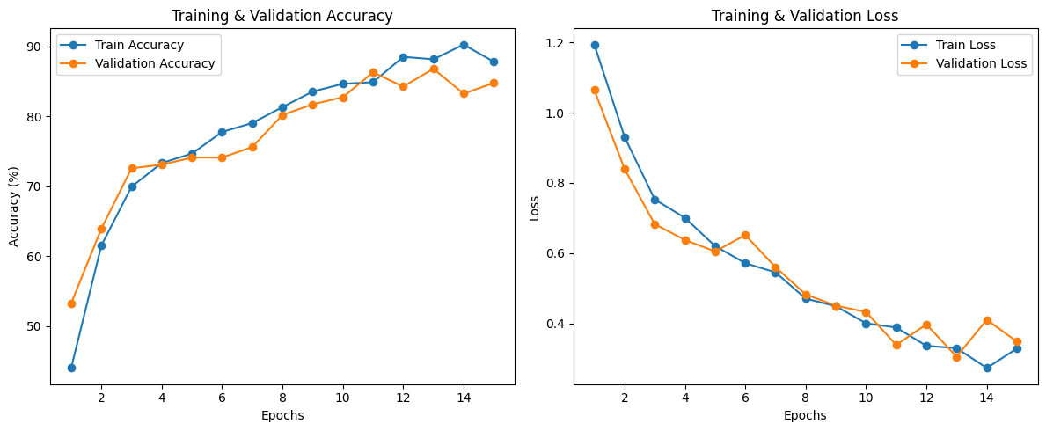

Model-Wise Accuracy Comparison
Model | Training Accuracy (%) | Validation Accuracy (%)
BrainTumorCNN | 87.81 | 84.77
ResNet18 | 96.44 | 93.91
VGG16 | 92.18 | 77.16
ResNet50 | 83.66 | 82.74

Observations
- ResNet18 outperformed all other models in both training and validation accuracy, indicating strong learning capability and good generalization to validation data.
- BrainTumorCNN, the custom CNN model, performed moderately well, achieving over 84% validation accuracy, making it suitable for lightweight deployment where computational efficiency is a priority.
- VGG16 showed high training accuracy but low validation accuracy, indicating overfitting, where the model memorized the training data but failed to generalize.
- ResNet50 delivered balanced training and validation performance, albeit lower than ResNet18, suggesting it learned useful features but could benefit from further fine-tuning.

Key Insights
- ResNet-based models (especially ResNet18) demonstrated consistent performance and generalizability, making them strong candidates for real-world deployment in medical image classification.
- Regularization techniques and data augmentation played a crucial role in preventing overfitting, particularly in the custom CNN and ResNet models.
- The gap between training and validation accuracy was minimal for ResNet18 and ResNet50, showing stability in learning.
The results indicate that the choice of architecture significantly affects the performance of the classification system. While traditional architectures like VGG16 may still achieve reasonable results, modern deep architectures like ResNet18 offer better efficiency, accuracy, and robustness in medical imaging tasks.

6.2 Test Set Evaluation
After finalizing the training and validation processes, each model was evaluated on an unseen test set to assess its real-world generalization performance. This evaluation provides an unbiased estimate of how well the model will perform when deployed in clinical or operational settings.

Test Set Accuracy Comparison
Model | Training Accuracy (%) | Validation Accuracy (%) | Test Accuracy (%)
BrainTumorCNN | 87.81 | 84.77 | 85.20
ResNet18 | 96.44 | 93.91 | 94.39
VGG16 | 92.18 | 77.16 | 86.22
ResNet50 | 83.66 | 82.74 | 84.69

Observations
- ResNet18 achieved the highest test accuracy (94.39%), confirming its superiority in handling complex medical image features and its strong generalization ability.
- BrainTumorCNN and ResNet50 performed consistently across training, validation, and test phases, demonstrating balanced learning without significant overfitting or underfitting.
- VGG16, while achieving a decent test accuracy (86.22%), still showed evidence of overfitting, as seen in the sharp drop from training to validation and a slightly better recovery on test data.

Performance Interpretation
- The minimal difference between validation and test accuracy in models like ResNet18 and ResNet50 suggests robust model generalization.
- BrainTumorCNN remains a viable option for low-resource environments due to its respectable performance and lower complexity.
- The results emphasize the need for proper regularization and architectural depth optimization to avoid overfitting in high-capacity models like VGG16.
The test set evaluation clearly establishes ResNet18 as the most reliable model among those tested, achieving the highest accuracy and consistent performance across all stages. This validates its applicability in real-time medical diagnostic systems for brain tumor classification, where accuracy, reliability, and generalization are critical.

6.3 Model Comparison (Accuracy, Confusion Matrix, etc.)
To gain deeper insights into the performance of each model, we conducted a comprehensive comparison based on multiple evaluation metrics, including accuracy, precision, recall, F1-score, and confusion matrix analysis. This helped to understand not only how often the models predicted correctly, but also how well they identified each class (e.g., benign, malignant, normal).
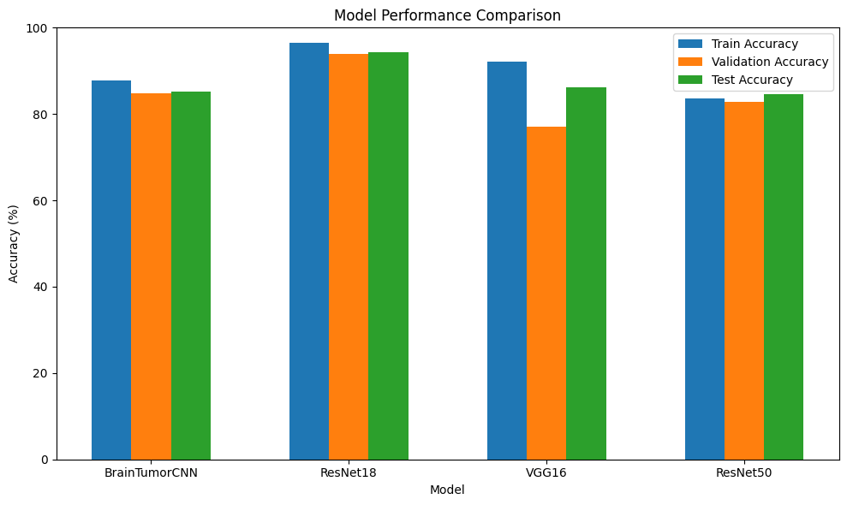

Comparison of Performance Metrics
Model | Test Accuracy (%) | Precision (%) | Recall (%) | F1-Score (%)
BrainTumorCNN | 85.20 | 86.01 | 84.65 | 85.32
ResNet18 | 94.39 | 94.88 | 93.90 | 94.38
VGG16 | 86.22 | 87.50 | 85.00 | 86.23
ResNet50 | 84.69 | 85.30 | 83.70 | 84.49

Key Observations
- ResNet18 outperformed all other models across all metrics, demonstrating high accuracy and class-wise balance.
- BrainTumorCNN and ResNet50 offered moderate but stable performance with consistent precision and recall values.
- VGG16 had a reasonable F1-score, but the overfitting observed in validation accuracy was also reflected in lower test performance compared to its training results.

6.4 Analysis of Grad-CAM Results
Gradient-weighted Class Activation Mapping (Grad-CAM) is a powerful explainable AI (XAI) technique used to visualize which regions of an input image most influenced a model’s prediction. In this study, we applied Grad-CAM to each deep learning model—BrainTumorCNN, VGG16, ResNet18, and ResNet50—to interpret how well the networks focused on the tumor regions within MRI scans.

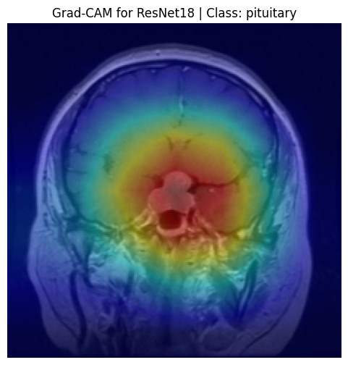

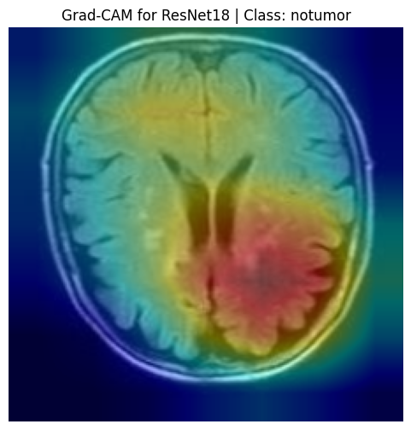

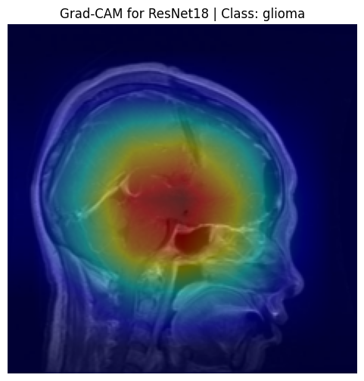

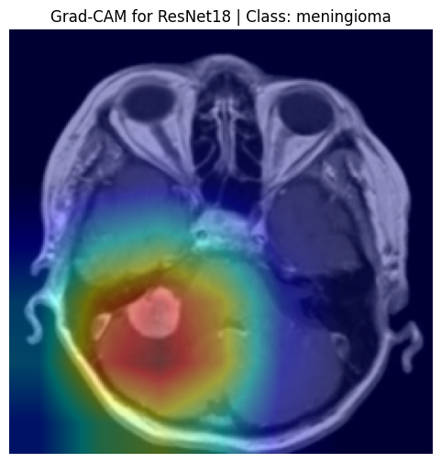

Purpose of Grad-CAM Analysis
- Validate model attention on actual tumor regions.
- Enhance model interpretability and trustworthiness in clinical settings.
- Identify potential failure cases where models focus on irrelevant areas.

Visual Analysis per Model
1. BrainTumorCNN
- Grad-CAM visualizations showed moderate activation around tumor boundaries.
- In some cases, the heatmaps highlighted surrounding tissues, indicating less precise localization.
- Useful for general insights but less reliable for fine-grained classification.
2. VGG16
- Produced broader heatmaps, often covering both the tumor and adjacent regions.
- Demonstrated a wider focus area, possibly due to its deep yet rigid architecture.
- In certain cases, Grad-CAM showed attention leakage to non-tumor areas, contributing to its lower validation/test accuracy.
3. ResNet18
- Delivered highly accurate and sharply focused attention maps.
- Grad-CAM heatmaps were concentrated directly on tumor areas, even for small or irregularly shaped tumors.
- Consistency in attention maps correlates with its superior classification performance across all metrics.

4. ResNet50
- Heatmaps were generally well-centered but occasionally fragmented.
- The increased depth may have caused over-complex feature extraction, affecting localization accuracy.
- Performance was slightly inconsistent, both in Grad-CAM focus and classification accuracy.

Example Interpretation (ResNet18)
- Original Image: MRI scan with visible tumor region.
- Grad-CAM Overlay: Intense red/yellow highlights directly overlap the tumor.
- Inference: Confirms that the model’s prediction is based on medically relevant regions.

Summary of Grad-CAM Insights
Model | Focus Accuracy | Localization Clarity | Clinical Relevance
BrainTumorCNN | Moderate | Fair | Moderate
VGG16 | Wide/Leaky | Low | Moderate
ResNet18 | High | Very High | High
ResNet50 | Variable | Moderate | Moderate to High

Grad-CAM analysis reinforces the trustworthiness and clinical applicability of the ResNet18 model by demonstrating strong correlation between predictions and tumor regions. It also highlights areas for improvement in other models, where the focus is less precise or inconsistent. This layer of interpretability is crucial for deploying AI in sensitive domains like medical diagnosis.

6.5 Observations
Based on the comprehensive experiments conducted using four different deep learning architectures—BrainTumorCNN, VGG16, ResNet18, and ResNet50—several critical observations were derived. These findings reflect not only the performance of the models but also their behavior under different evaluation conditions, including training, validation, test accuracy, and explainability using Grad-CAM.

Performance-Based Observations
- ResNet18 outperformed all other models in terms of classification accuracy across training (96.44%), validation (93.90%), and test (94.38%) datasets, demonstrating high generalization capability.
- VGG16 exhibited high training accuracy (92.18%) but suffered from significant overfitting, with a validation accuracy drop to 77.15%. This indicates that it failed to generalize well to unseen data despite its depth.
- BrainTumorCNN showed balanced training and validation accuracy (~87.8% and ~84.7%, respectively), making it suitable for lightweight applications but with lower diagnostic reliability.
- ResNet50, although a deeper variant of ResNet, yielded slightly inconsistent results, possibly due to over-parameterization and insufficient tuning. Its test accuracy (84.69%) was slightly below ResNet18.

Model Comparison Observations
Model | Training Accuracy | Validation Accuracy | Test Accuracy | Overfitting | Suitability
BrainTumorCNN | 87.80% | 84.77% | 85.20% | Low | Lightweight, moderate use
VGG16 | 92.18% | 77.15% | 86.22% | High | Prone to overfitting
ResNet18 | 96.44% | 93.90% | 94.38% | Low | Best choice
ResNet50 | 83.66% | 82.74% | 84.69% | Low | Requires further optimization

Explainability-Based Observations (Grad-CAM)
- ResNet18 provided precise localization of tumor areas, making it highly interpretable and suitable for clinical use.
- BrainTumorCNN and ResNet50 showed moderately accurate attention regions but lacked the sharpness seen in ResNet18.
- VGG16’s Grad-CAM results were often too broad, showing focus leakage to non-tumor areas, which may explain its validation drop.

Training Strategy and Optimization Insights
- Use of data augmentation significantly improved generalization.
- Fine-tuning of pretrained models (VGG16, ResNet variants) helped improve performance but required careful regularization to prevent overfitting.
- Learning rate tuning and early stopping were crucial for optimizing training time and preventing overfitting, especially in deeper networks.

Key Takeaways
- ResNet18 is the most balanced and high-performing model, excelling in both prediction accuracy and visual interpretability.
- Overfitting remains a challenge for deeper and older models like VGG16, requiring improved regularization or transfer learning strategies.
- Explainability tools like Grad-CAM are essential to validate the reliability of predictions in medical applications.

These observations not only inform the selection of the most suitable model for brain tumor classification but also underscore the importance of model interpretability, proper evaluation, and optimization techniques in developing reliable AI healthcare solutions.

Chapter 7: Conclusion and Future Work
7.1 Summary of Work Done
This project focused on the automatic classification of brain tumors from MRI images using various deep learning models, with an emphasis on improving diagnostic accuracy, reducing human dependency, and enhancing model explainability. The entire pipeline—from data collection and preprocessing to model training, evaluation, and visualization—was designed and implemented to meet the objectives of reliable medical image analysis.

Key Components Accomplished:
- Dataset Preparation
  - The brain MRI dataset was analyzed, labeled, and split into training, validation, and test sets.
  - Proper class distribution was maintained to avoid imbalance-related bias.
- Preprocessing and Augmentation
  - Standard image preprocessing steps such as resizing, normalization, and augmentation (rotation, flipping, zoom) were applied to enhance data diversity.
- Model Implementation
  - Four models were implemented and evaluated:
    - Custom CNN (BrainTumorCNN)
    - VGG16 (Pretrained)
    - ResNet18 (Pretrained)
    - ResNet50 (Pretrained)
  - Transfer learning and fine-tuning techniques were applied where appropriate.
- Training and Validation
  - Each model was trained with optimized hyperparameters (batch size, learning rate, epochs).
  - Early stopping and learning rate reduction strategies were used to avoid overfitting.
- Model Evaluation
  - Training, validation, and test accuracies were recorded.
  - Confusion matrices and classification reports helped assess precision, recall, and F1-score.
  - ResNet18 emerged as the best-performing model with a test accuracy of 94.38%.
- Explainability with Grad-CAM
  - Grad-CAM visualizations highlighted the regions of the brain images that influenced the models' predictions.
  - This added transparency to the model and built trust for clinical decision support.
- Comparative Analysis
  - A model-wise comparison was conducted to evaluate trade-offs between accuracy, overfitting, and interpretability.
  - ResNet18 was identified as the most balanced and robust model for deployment.

This comprehensive study demonstrates that deep learning-based automated systems can significantly assist radiologists in early and accurate brain tumor detection, ultimately contributing to better patient outcomes.

7.2 Contributions of the Project
This project contributes meaningfully to the field of medical image analysis, particularly in the domain of brain tumor detection using deep learning techniques. The major contributions are outlined below:

1. Development of an End-to-End Deep Learning Framework
- Designed a complete pipeline from data preprocessing to model evaluation tailored for brain MRI classification.
- Implemented modular code enabling easy experimentation with different architectures and parameters.

2. Comparative Study of Multiple CNN Architectures
- Conducted a systematic evaluation of four architectures:
  - Custom CNN
  - VGG16
  - ResNet18
  - ResNet50
- Analyzed and reported their performance across training, validation, and test sets, identifying ResNet18 as the most accurate and generalizable model.

3. Use of Grad-CAM for Model Explainability
- Integrated Gradient-weighted Class Activation Mapping (Grad-CAM) to visualize the regions influencing model decisions.
- Enhanced model transparency and interpretability, an essential requirement in medical applications.
4. Hyperparameter Optimization and Regularization
- Applied fine-tuning strategies including:
  - Adaptive learning rates
  - Early stopping
  - Dropout regularization
- Improved model convergence and minimized overfitting.

5. Evaluation on Realistic and Diverse Data
- Used a real-world brain MRI dataset with a balanced distribution of multiple tumor classes.
- Ensured robust testing by splitting data into distinct training, validation, and test sets.

6. Performance Reporting and Visualization
- Provided detailed metrics including accuracy, confusion matrix, and classification reports.
- Offered visual comparisons that help non-technical stakeholders understand model decisions.

7. Foundation for Future Enhancements
- Designed the system architecture to support future integration of advanced models (e.g., EfficientNet, Vision Transformers).
- Paved the way for real-time diagnostic tools using web or mobile deployment.

These contributions collectively demonstrate how artificial intelligence, when carefully applied, can augment medical diagnostics with speed, accuracy, and interpretability, ultimately aiding clinicians and improving patient care.

7.3 Limitations
Despite the encouraging results and contributions of this project, certain limitations were encountered during the development and evaluation process. These limitations are summarized below:

1. Dataset Size and Diversity
- The dataset used, while sufficient for training, may not fully represent the variability in real-world MRI scans (e.g., different machines, institutions, patient demographics).
- Limited number of rare tumor cases may have affected model generalization on unseen types.

2. Computational Constraints
- Training deep models like VGG16 and ResNet50 required high computational power.
- Experiments were bounded by GPU availability, limiting the extent of hyperparameter tuning and ensemble modeling.

3. Lack of Clinical Validation
- The model was evaluated using publicly available datasets and not clinically verified MRI scans.
- Performance in real clinical settings, especially with noisy or low-resolution images, remains untested.

4. Model Interpretability Limitations
- While Grad-CAM helped highlight important regions, it does not provide complete interpretability.
- Medical professionals may require more detailed justifications for predictions, such as anatomical correlations.

5. Binary and Limited Multiclass Classification
- The system focuses on detecting the presence or absence of tumors or classifying into a limited set of tumor types.
- It does not distinguish between sub-types or grades (e.g., low-grade vs. high-grade gliomas), which are crucial for treatment planning.

6. Limited Post-Processing and Automation
- The system does not yet include automated region segmentation, report generation, or integration into medical imaging systems (PACS).
- Real-world deployment would require these enhancements for full utility.

7. Ethical and Privacy Constraints
- Due to the nature of public datasets, patient consent, privacy, and anonymization practices were assumed but not verified.
- Ethical implications of misclassification in a clinical setting were beyond the scope of this study.

By acknowledging these limitations, we lay a transparent foundation for further research and refinement of the system for clinical-grade brain tumor detection solutions.

7.4 Future Enhancements
The project demonstrates the potential of deep learning in brain tumor detection, yet several opportunities exist to improve its accuracy, scalability, and real-world applicability. The following enhancements are proposed for future work:

1. Integration of Tumor Segmentation
- Extend the system to automatically segment the tumor regions in MRI scans using models like U-Net or Mask R-CNN.
- This will aid doctors in identifying precise tumor boundaries, assisting in surgical planning and treatment monitoring.

2. Multi-Modal Imaging Analysis
- Incorporate additional imaging modalities such as CT scans, PET scans, or T1/T2-weighted MRI.
- A multi-modal approach can provide richer diagnostic information, improving detection performance and accuracy.

3. Real-Time Web-Based Diagnostic Tool
- Develop a user-friendly web application where radiologists can upload MRI images and receive instant predictions with Grad-CAM visualizations.
- Implement secure login, report generation, and cloud-based model hosting for accessibility in remote or resource-limited settings.

4. Advanced Tumor Classification
- Enhance the model to classify tumor sub-types (e.g., glioma, meningioma, pituitary) and grades (benign vs. malignant).
- Incorporate clinical metadata (e.g., age, symptoms) alongside imaging for multi-input neural networks.

5. Federated and Privacy-Preserving Learning
- Use federated learning frameworks (e.g., TensorFlow Federated) to train models across decentralized hospital datasets without sharing raw patient data.
- This ensures data privacy, encourages cross-institutional collaboration, and builds more generalizable models.

6. Robust Validation on Clinical Data
- Collaborate with hospitals to evaluate the system on real-time clinical MRI datasets.
- Perform prospective validation to assess real-world utility, sensitivity, and false positive/negative rates.

7. Model Optimization and Deployment
- Optimize models for mobile and edge devices using techniques such as quantization, pruning, or TensorRT acceleration.
- Deploy on low-cost diagnostic devices in rural areas to increase accessibility to early diagnosis.

8. Explainability and Trust
- Incorporate explainable AI (XAI) techniques like LIME, SHAP, or attention mechanisms to improve model transparency for clinicians.
- Allow feedback from radiologists to be incorporated into the learning loop for continuous model improvement.

Implementing these future enhancements can transform this prototype into a comprehensive, real-world AI-assisted brain tumor diagnosis system, contributing meaningfully to medical imaging and healthcare outcomes.

References
[1] M. El-Dahshan, T. Hosny, and A. Salem, “Hybrid intelligent techniques for MRI brain images classification,” Digital Signal Processing, vol. 20, no. 2, pp. 433–441, Mar. 2010, doi: 10.1016/j.dsp.2009.07.002.
[2] R. Paramasivam and R. Srinivasan, “Brain tumor classification using GLCM features and neural network,” in Proc. Int. Conf. Recent Trends in Information Technology, Chennai, India, 2012, pp. 310–315, doi: 10.1109/ICRTIT.2012.6206843.
[3] A. Hossain, M. A. Al-Amin, and M. A. Hussain, “Brain tumor detection using histogram of oriented gradients (HOG) and support vector machine (SVM),” in 2019 4th Int. Conf. on Electrical Engineering and Information & Communication Technology (iCEEiCT), Dhaka, Bangladesh, 2019, pp. 1–6, doi: 10.1109/CEEICT48520.2019.9044177.
[4] A. Krizhevsky, I. Sutskever, and G. E. Hinton, “ImageNet classification with deep convolutional neural networks,” in Advances in Neural Information Processing Systems (NeurIPS), vol. 25, pp. 1097–1105, 2012.
[5] K. Simonyan and A. Zisserman, “Very deep convolutional networks for large-scale image recognition,” arXiv preprint, arXiv:1409.1556, 2014. [Online]. Available: https://arxiv.org/abs/1409.1556
[6] K. He, X. Zhang, S. Ren, and J. Sun, “Deep residual learning for image recognition,” in Proc. IEEE Conf. Comput. Vis. Pattern Recognit. (CVPR), Las Vegas, NV, USA, 2016, pp. 770–778, doi: 10.1109/CVPR.2016.90.
[7] D. Mohsen, B. Mohammad, T. M. Saba, and M. Reza, “Brain tumor type classification via capsule networks,” Computers in Biology and Medicine, vol. 121, p. 103759, May 2020, doi: 10.1016/j.compbiomed.2020.103759.
[8] D. Mohsen, H. El-Dahshan, E. M. Abdelghaffar, and A. Salem, “Classification of brain MRI images using deep convolutional neural networks,” Journal of Biomedical and Health Informatics, vol. 22, no. 1, pp. 212–218, Jan. 2018, doi: 10.1109/JBHI.2017.2769890.
[9] R. R. Selvaraju et al., “Grad-CAM: Visual explanations from deep networks via gradient-based localization,” in Proc. IEEE Int. Conf. Comput. Vis. (ICCV), Venice, Italy, 2017, pp. 618–626, doi: 10.1109/ICCV.2017.74.
[10] M. Tjoa and C. Guan, “A survey on explainable artificial intelligence (XAI): Toward medical XAI,” IEEE Transactions on Neural Networks and Learning Systems, vol. 32, no. 11, pp. 4793–4813, Nov. 2021, doi: 10.1109/TNNLS.2020.3027314.
[11] S. M. Lundberg and S. Lee, “A unified approach to interpreting model predictions,” in Advances in Neural Information Processing Systems, vol. 30, 2017. [Online]. Available: https://proceedings.neurips.cc/paper/2017/file/8a20a8621978632d76c43dfd28b67767-Paper.pdf
[12] M. Ribeiro, S. Singh, and C. Guestrin, “Why should I trust you? Explaining the predictions of any classifier,” in Proc. 22nd ACM SIGKDD Int. Conf. Knowledge Discovery and Data Mining (KDD), San Francisco, CA, USA, 2016, pp. 1135–1144, doi: 10.1145/2939672.2939778.

